SFA24

<https://www.facebook.com/photo/?fbid=564519876441529&set=pcb.1158880189145425>

True or False: The start time of the project (the early start of the first activity) can be "zero" or "one" depending on your chosen convention.

A. False

B. True

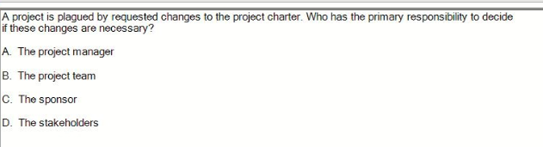

C the sponsor

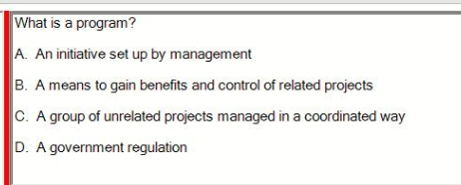

B

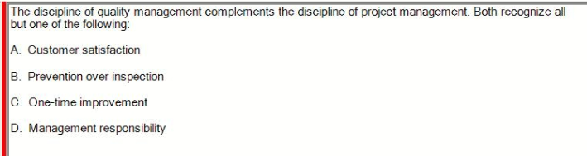

C One-time improvement

Note: Management satisfaction

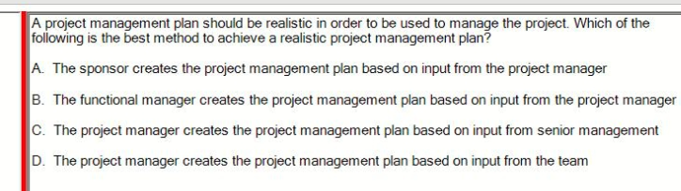

D

If we were to rephrase the question, it would be asking, “Who creates the project management plan?” The best answer is that the project management plan is created by the project manager but requires input from the team.

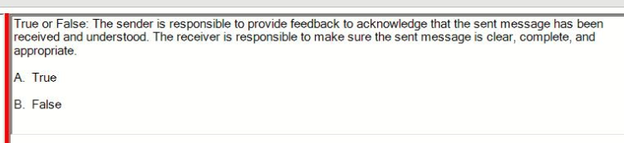

F

In communication, the **sender** is responsible for ensuring that the message is clear, complete, and appropriate. This includes making sure the message is well-constructed and free from misunderstandings before sending it.

The **receiver**, on the other hand, is responsible for **acknowledging** the message and providing **feedback** to ensure that the message has been received and understood correctly.

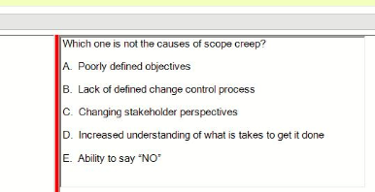

E

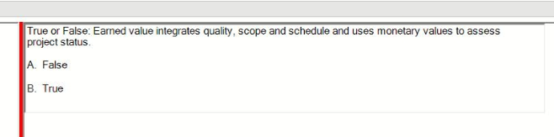

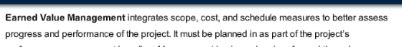

Maybe true (checking) ***false***

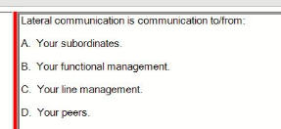

D (ngang hàng )

Up -> Senior management

Down -> The direct

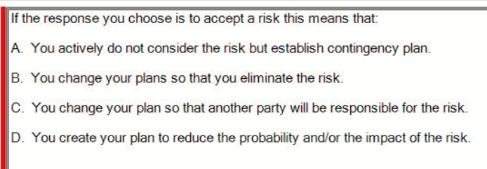  
A

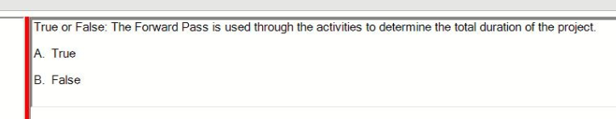

A true

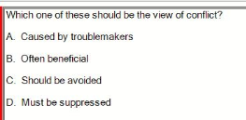

B often beneficial (current view)

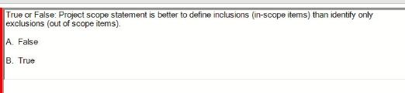

***true***

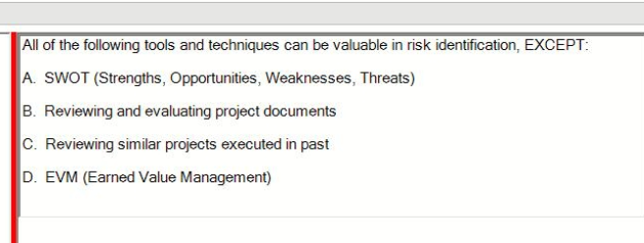***D***

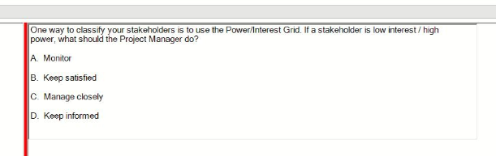

B

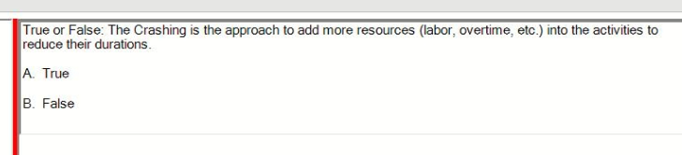

***true***

False ( Fast Tracking)

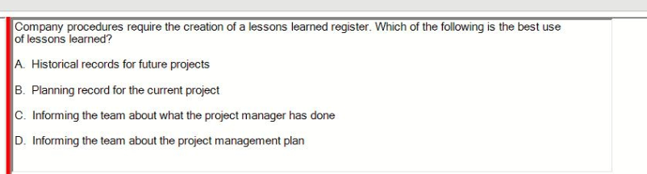

A

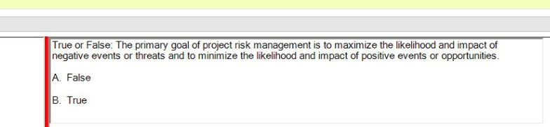

A false

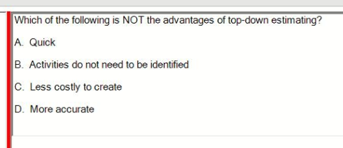

D

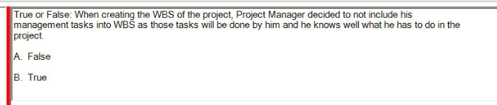

A false

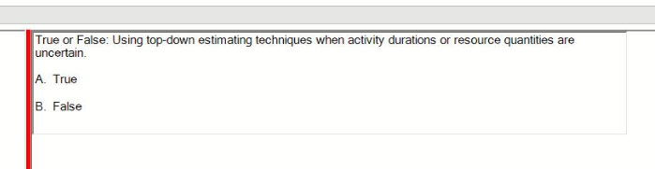

true

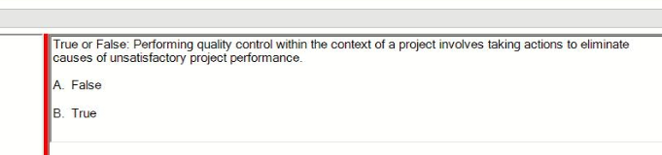

true

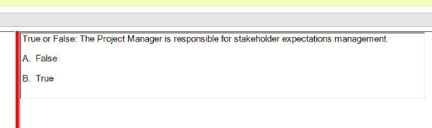

A false ***true***

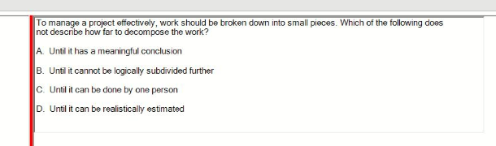

C

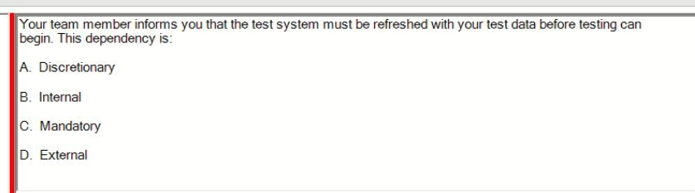

C

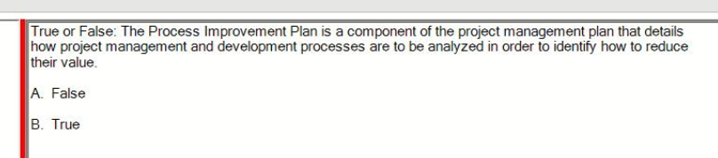

A false (sai ở reduce their value)

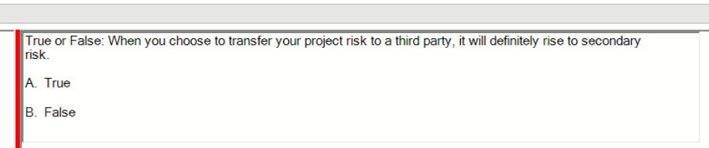

FALSE

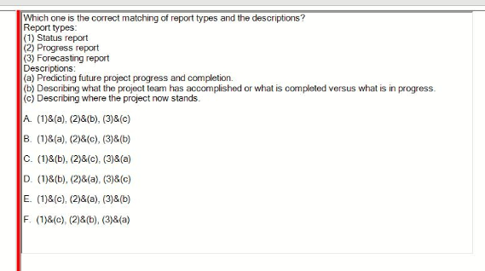

F

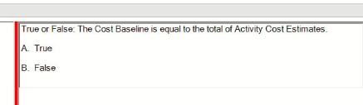

FALSE

Su24 retake

<https://www.facebook.com/photo/?fbid=474155728845792&set=pcb.1079931750373603>

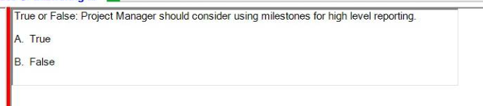

True

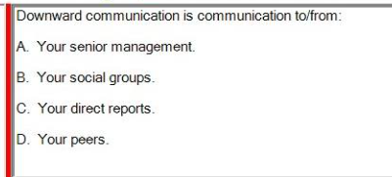

Downward : C

Upward : A

Lateral: D

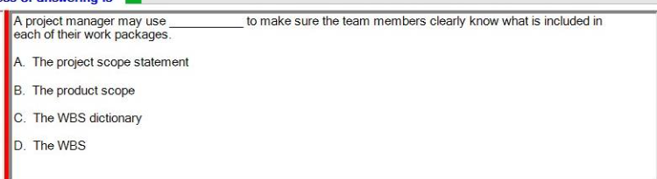

C

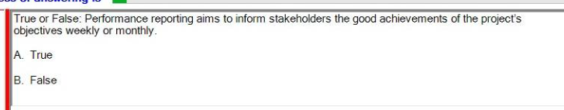

False (weekly or monthly)

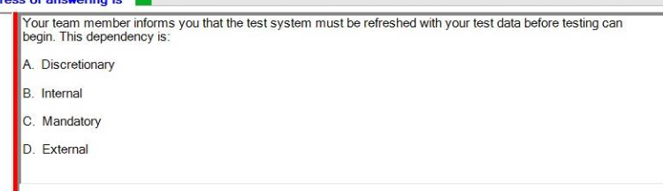

Team member -> C

Sponsor -> D

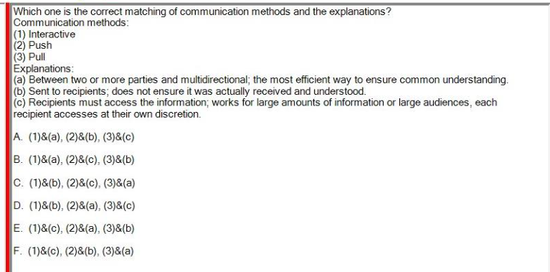

A

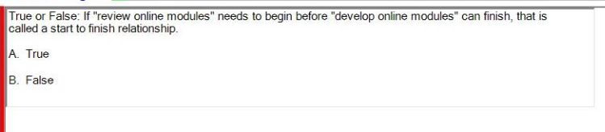

True

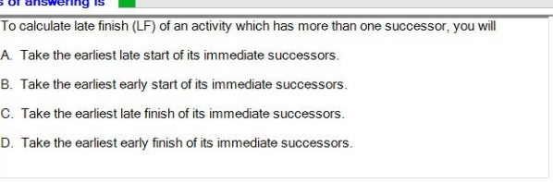

A

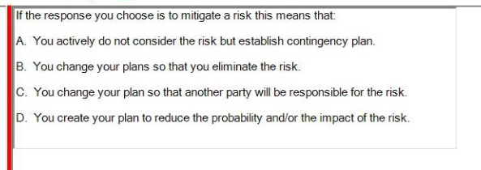

Mitiagate -> D

Accept -> A

Avoid -> B

Transfer -> C

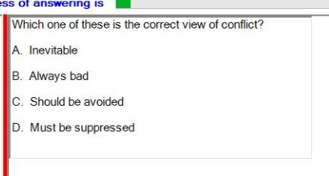

A  
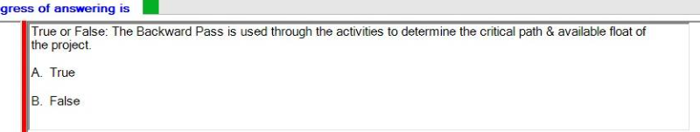

True

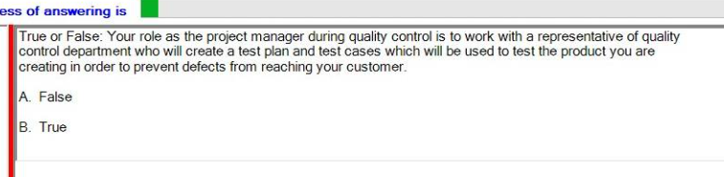

False ( tester)

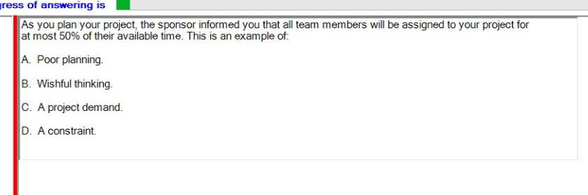

D constraint

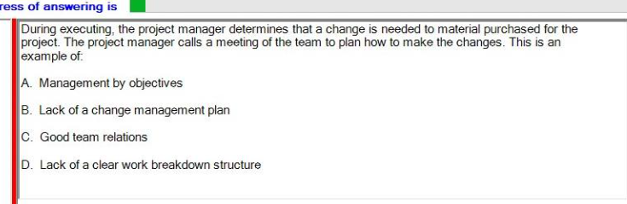

B

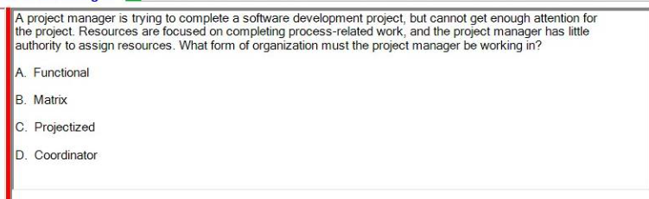

A

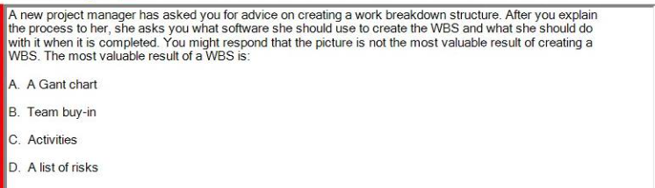

B

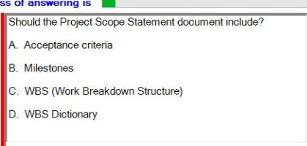

A ?

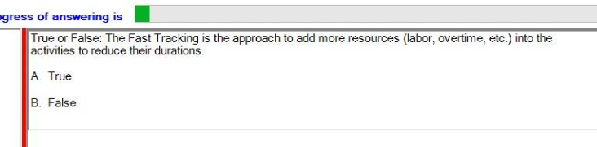

F

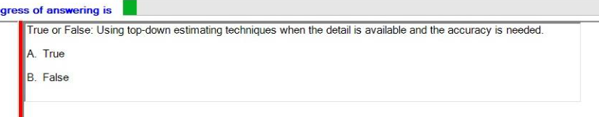

False ( top-down -> low accuracy)

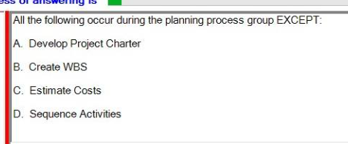

A

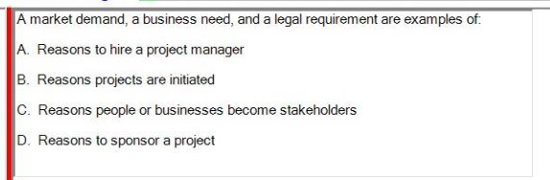

B

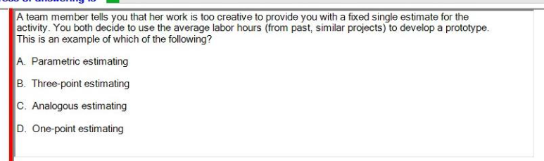

A?

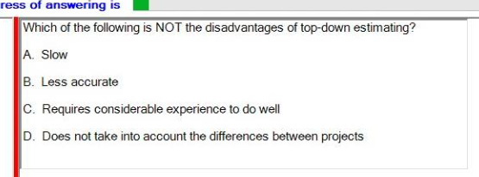

A slow

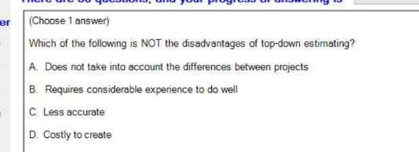

D

Costly to create

Su24 <https://www.facebook.com/photo?fbid=473598678900240&set=pcb.1075058214194290>

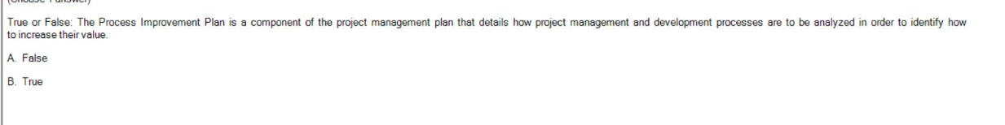

T

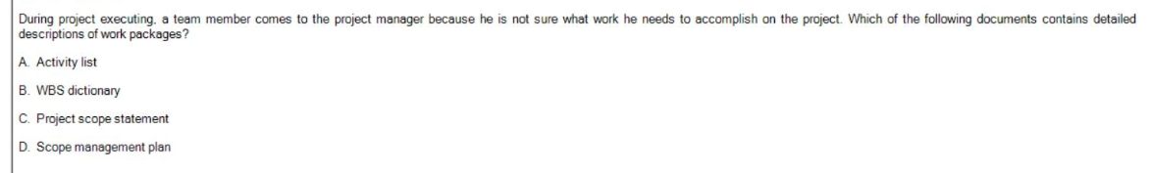

B

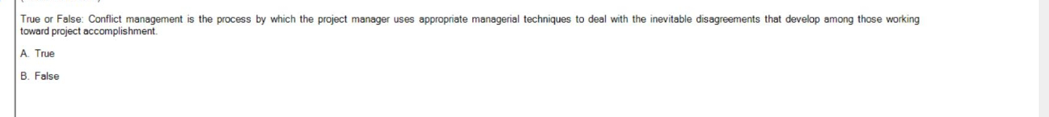

A TRUE

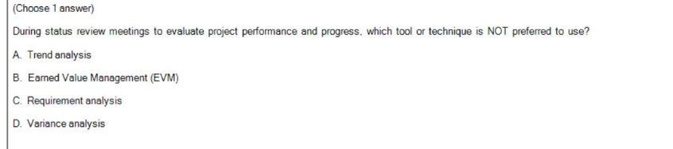

***C?***

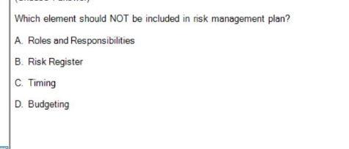

B

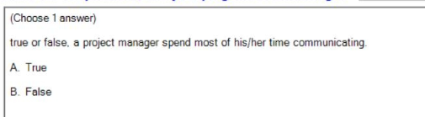

A TRUE

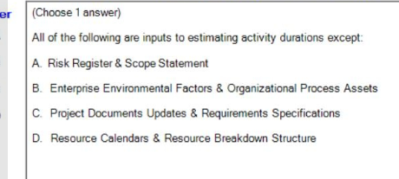

C

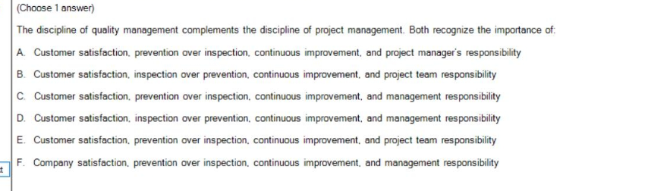

C

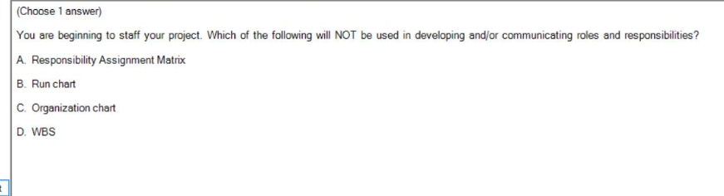

B

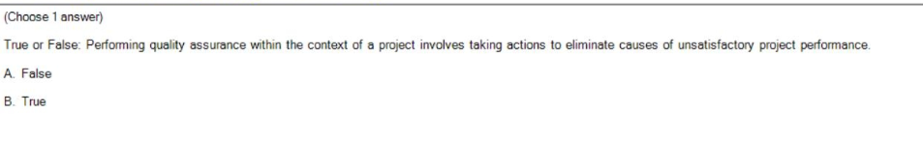

T

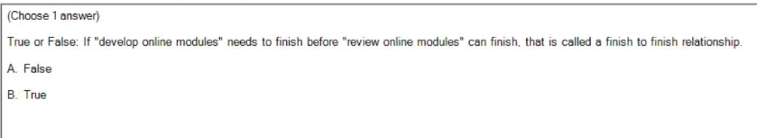

T

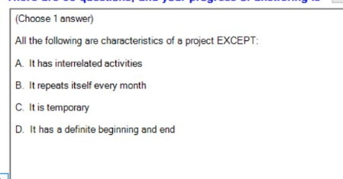

B

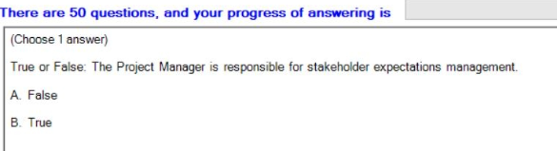

True (Nếu là “the project sponsor” -> false)

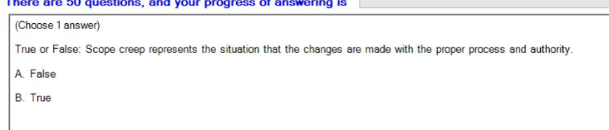

F

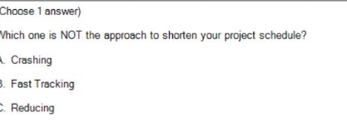

C

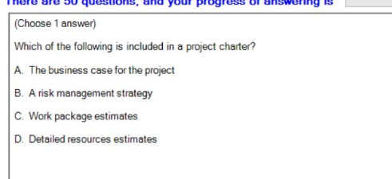

A

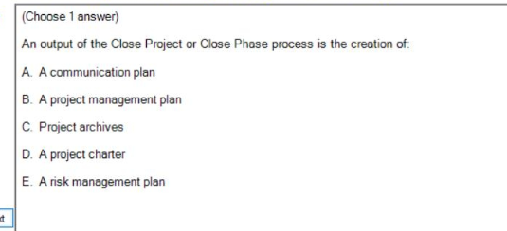

C

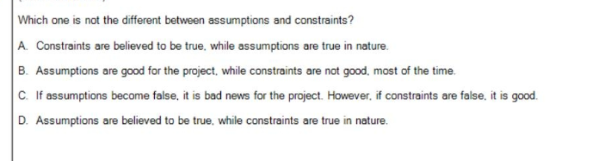

A

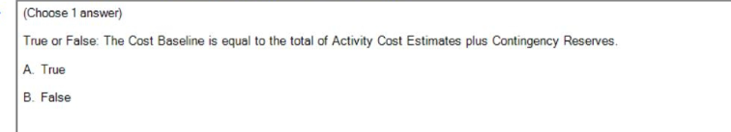

T ?

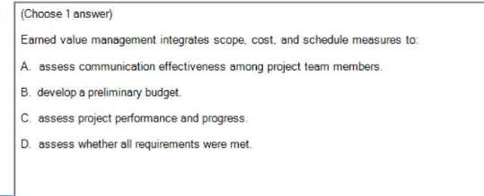

C

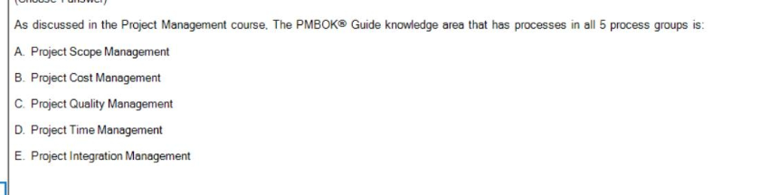

E

Sp24 <https://www.facebook.com/photo/?fbid=298654346600066&set=pcb.995221678844611>

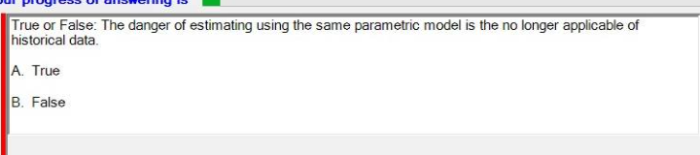

A true

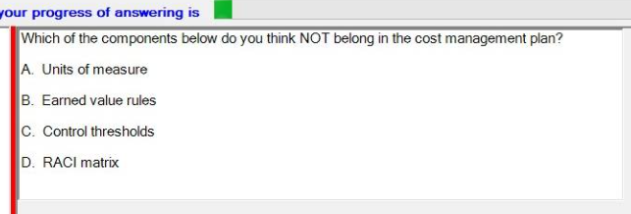

D raci matrix

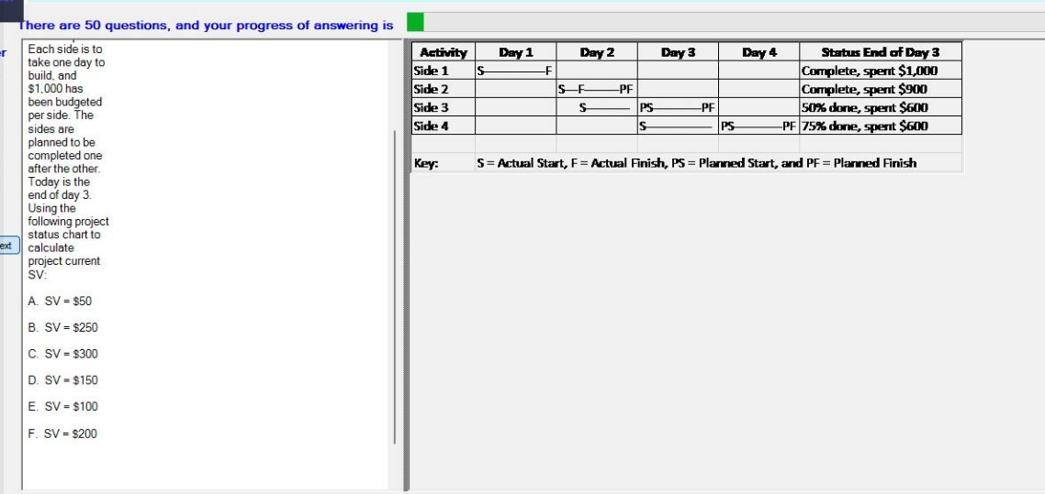

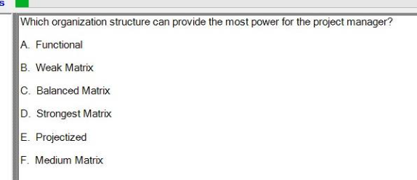

A ***E?***

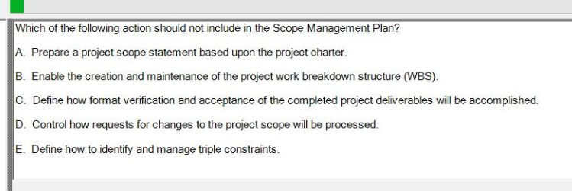

E?

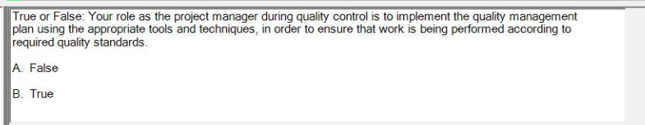

T

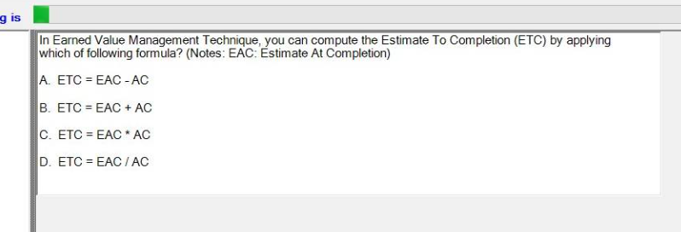

A

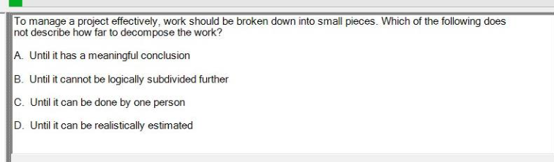

C

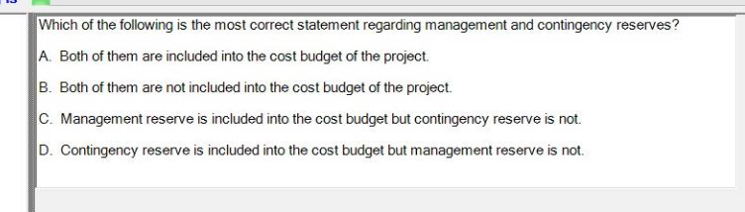

D

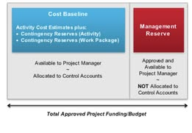

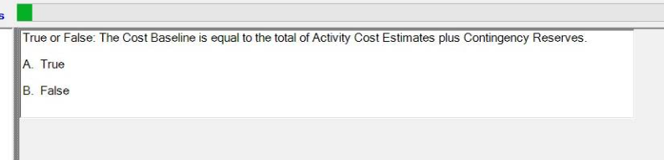

A true

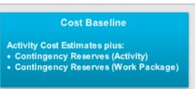

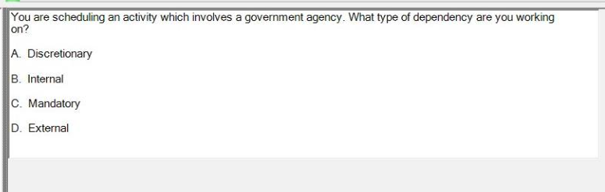

D

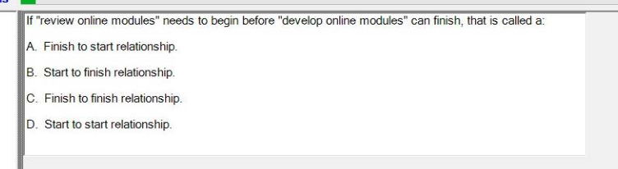

B

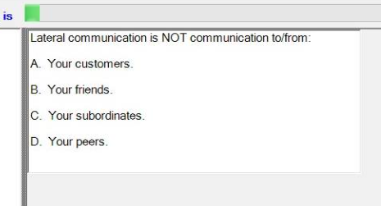

C

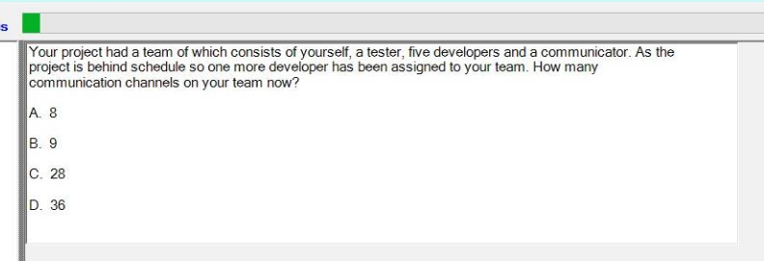

D 36

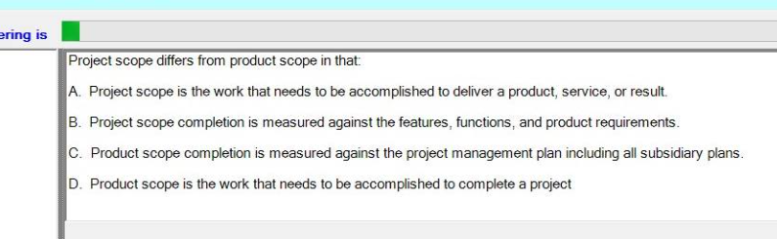

A

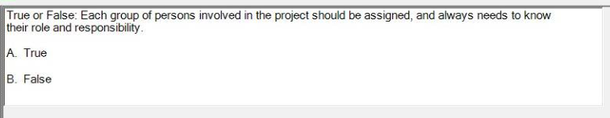

TRUE

(needs to know-> True but doesn't always needs to know-> False)

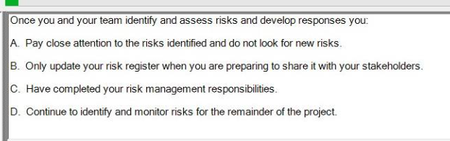

D

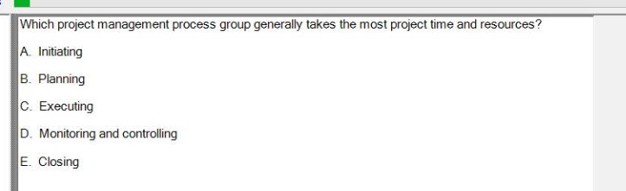

C

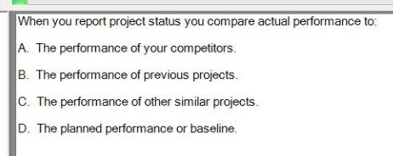

D

sp24 re <https://www.facebook.com/photo/?fbid=303067309492103&set=pcb.999765091723603>

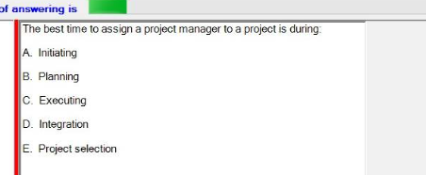

A

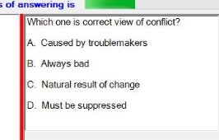

C (current view )

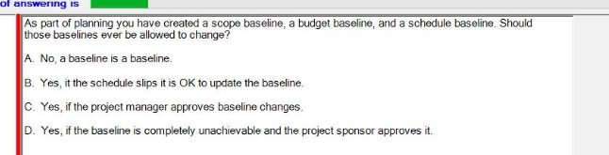

D

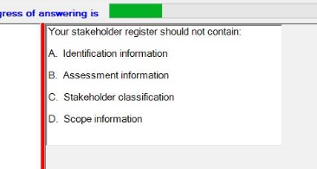

D scope

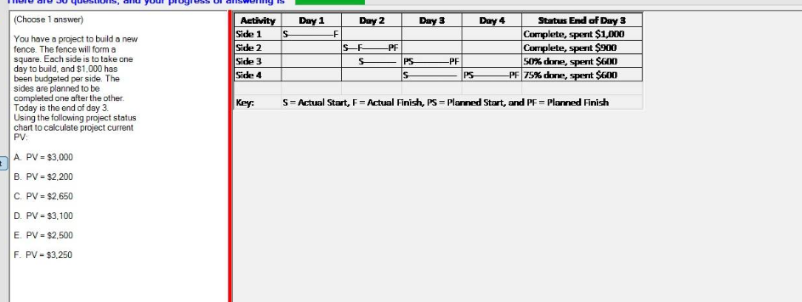

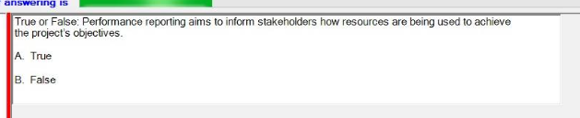

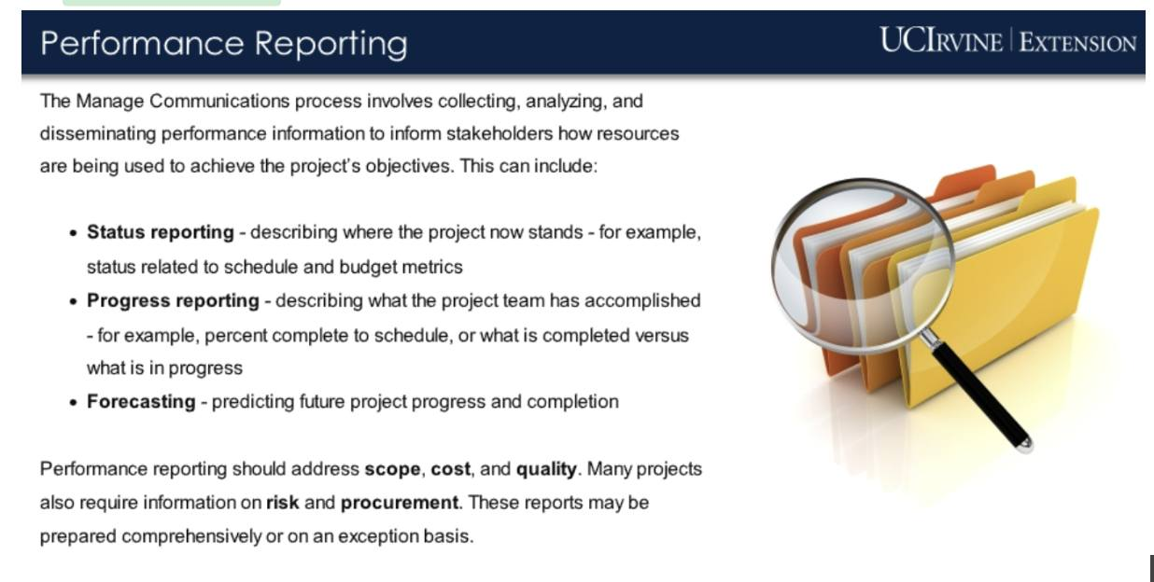

A

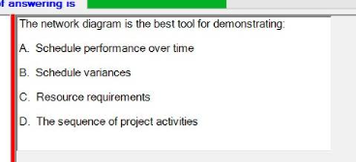

D

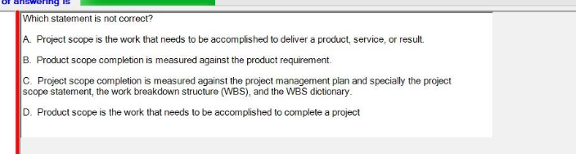

D (phải là project scope)

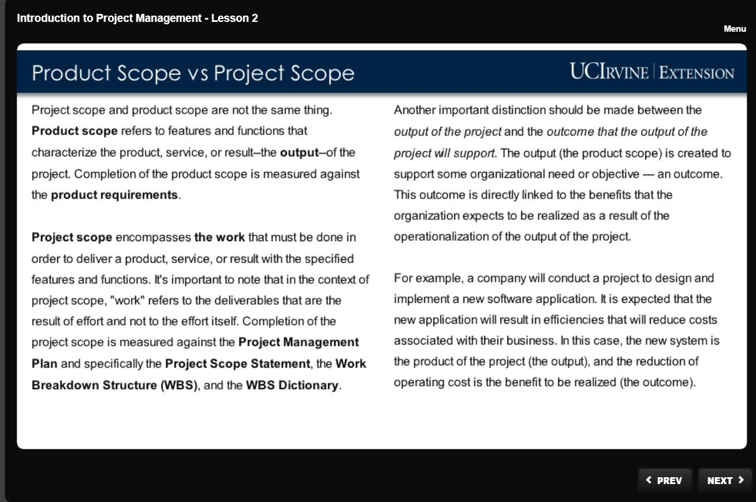

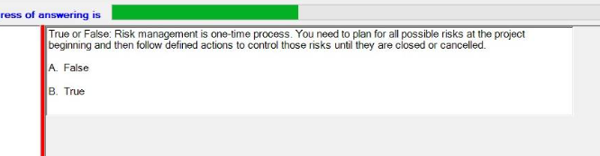

False (risk is on-going process)

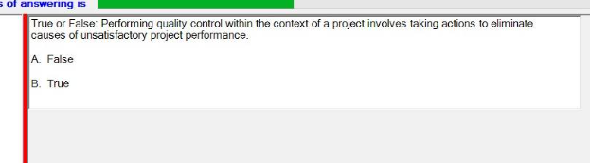

B true

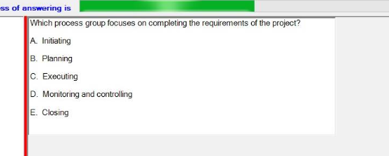

C

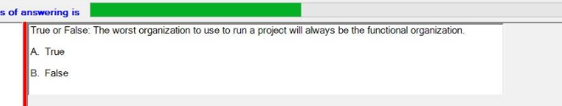

B

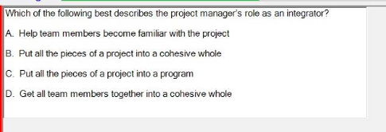

B

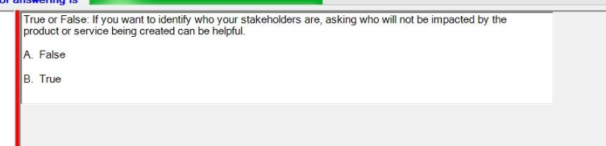

FALSE

Asking who will not be impacted by the product or service being created can be helpful = False

Asking who will use the product or service being created can be helpful = True

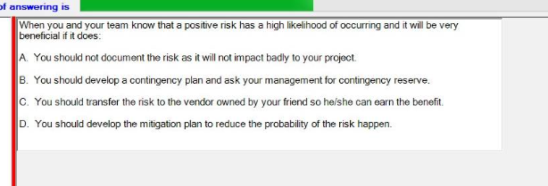

B

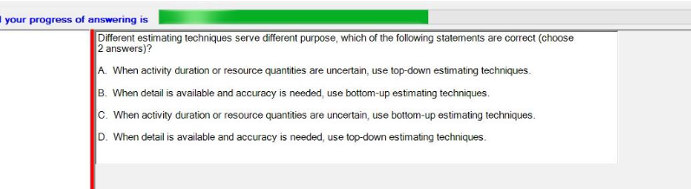

AB

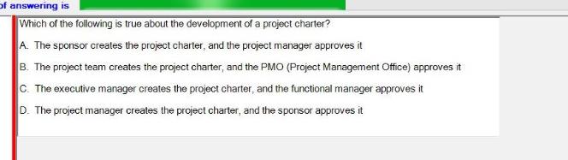

D

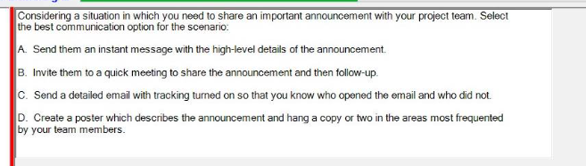

B

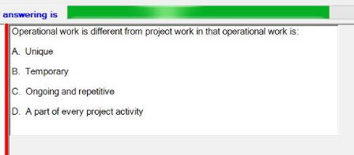

C

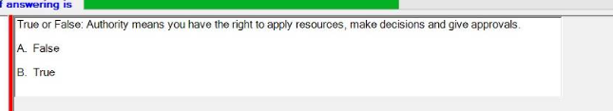

B

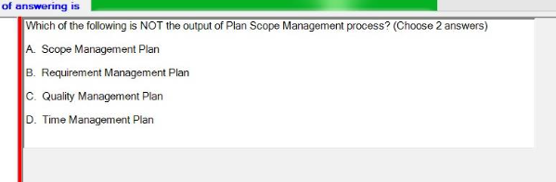

CD

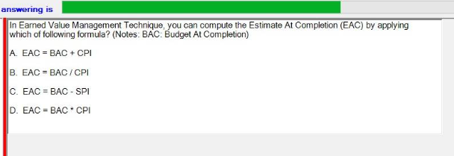

B

Re fall23

<https://www.facebook.com/photo/?fbid=318061394455227&set=pcb.916486970051416>

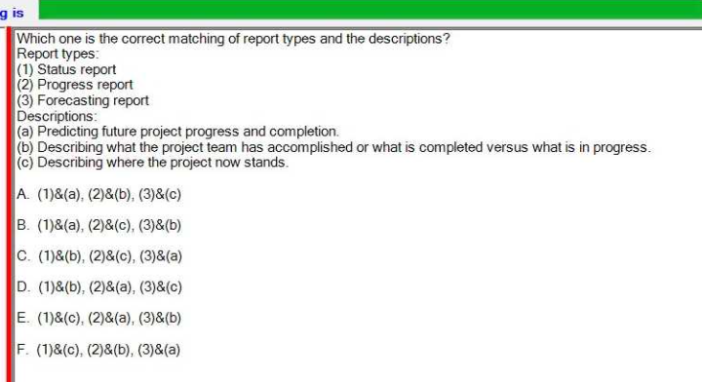

F

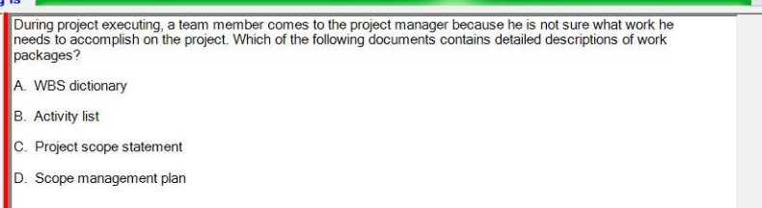

A

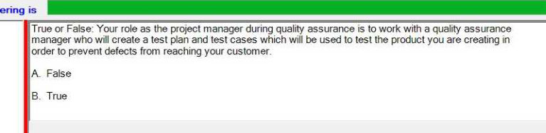

T

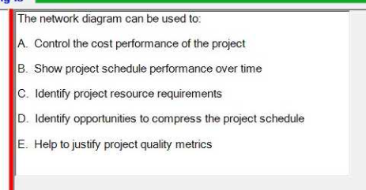

B

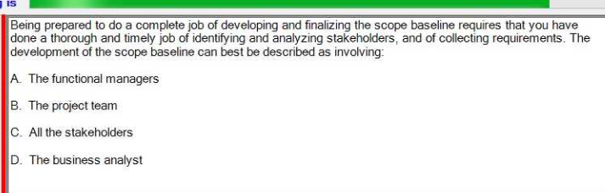

B

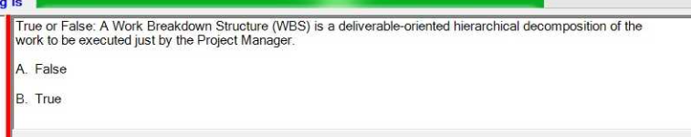

F

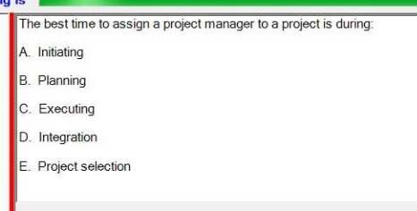

the best time -> initiating

Which project management -> executing

=> chọn A

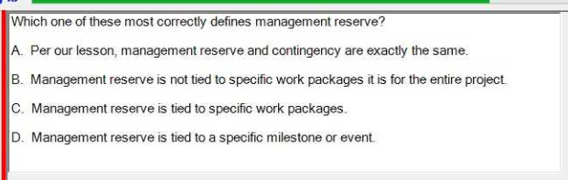

management reserve -> is not tied

contingency reserve -> is tied to specific work packages or activities.

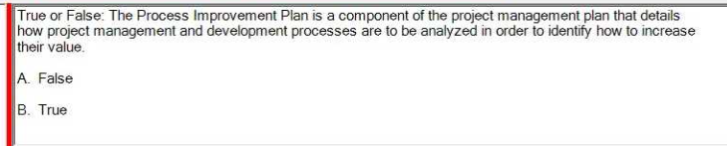

B true ( note increase in the last sentence)

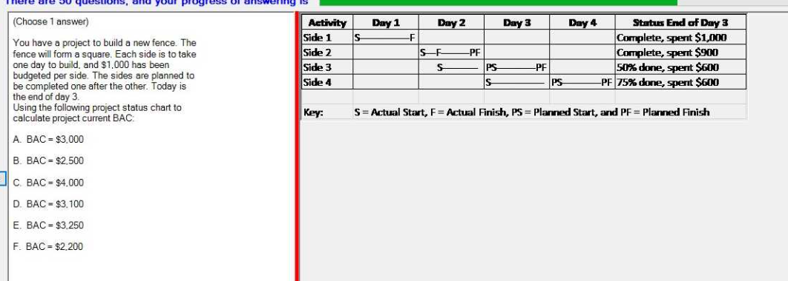

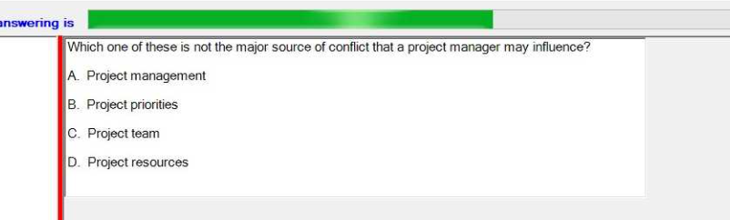

A

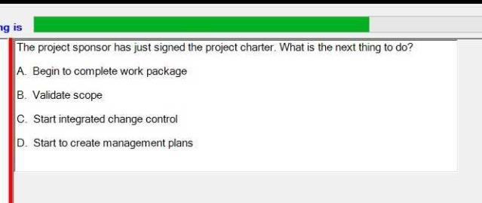

D

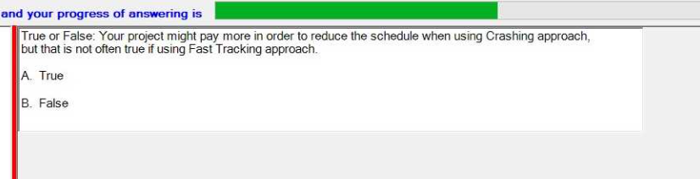

***B? TRUE ?***

Re su23

<https://www.facebook.com/photo/?fbid=253393327588701&set=pcb.852335466466567>

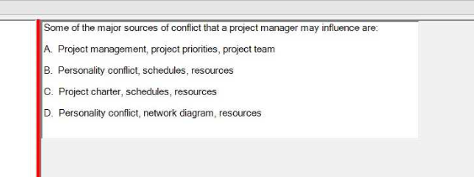

B

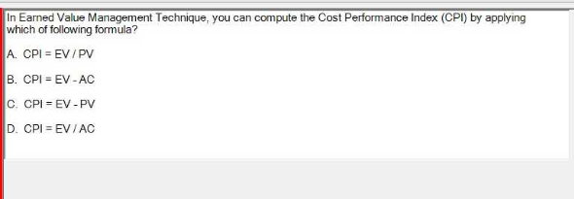

D

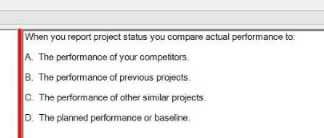

D

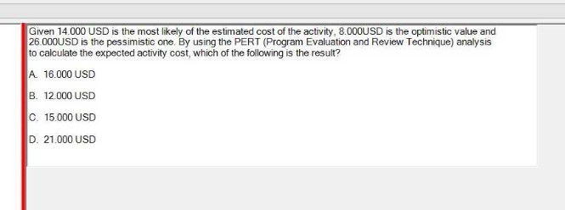

C

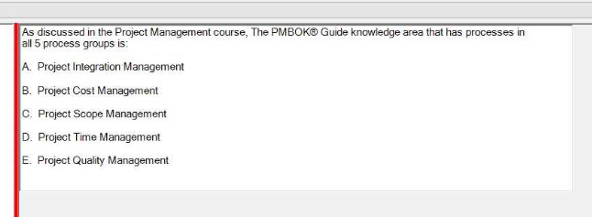

MAYBE a A

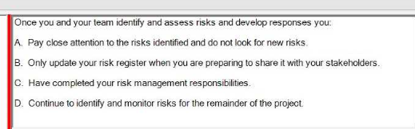

D

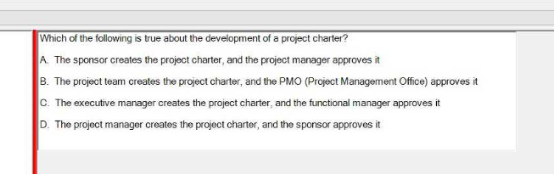

D

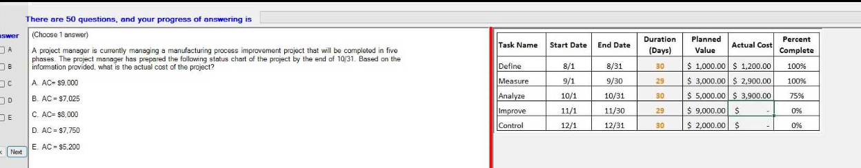

Su23 <https://www.facebook.com/photo/?fbid=249175761343791&set=pcb.847339803632800>

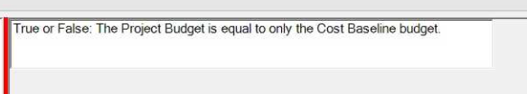

False

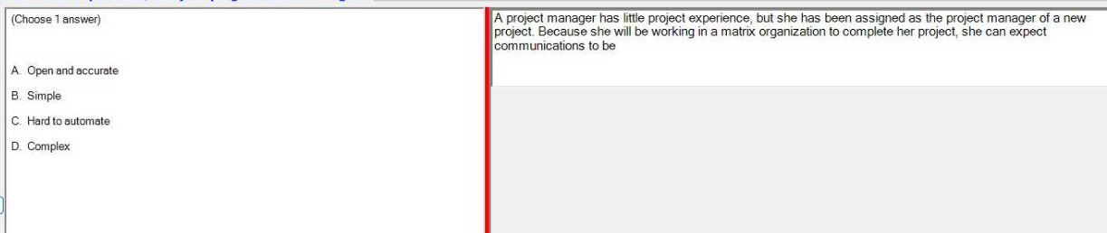

D

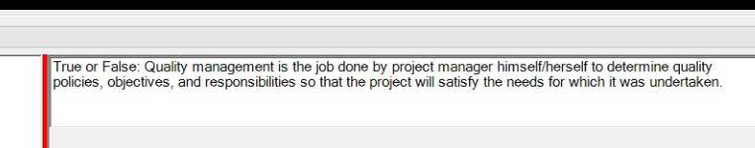

F

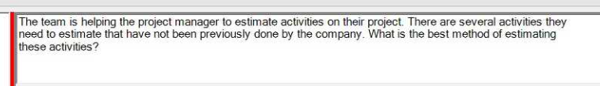

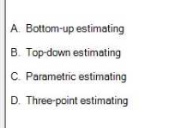

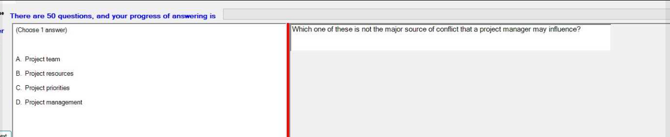

D (Project management itself is not typically considered a source of conflict. Conflictsusually arise from issues related to the project team, project resources, and project priorities, all of which the project manager may influence).

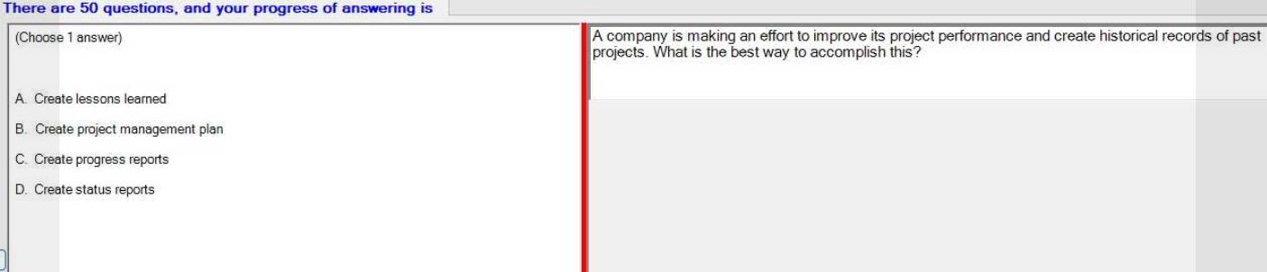

A

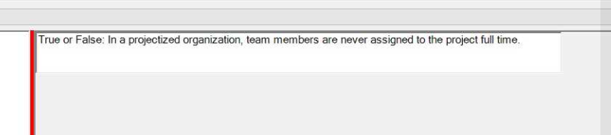

false

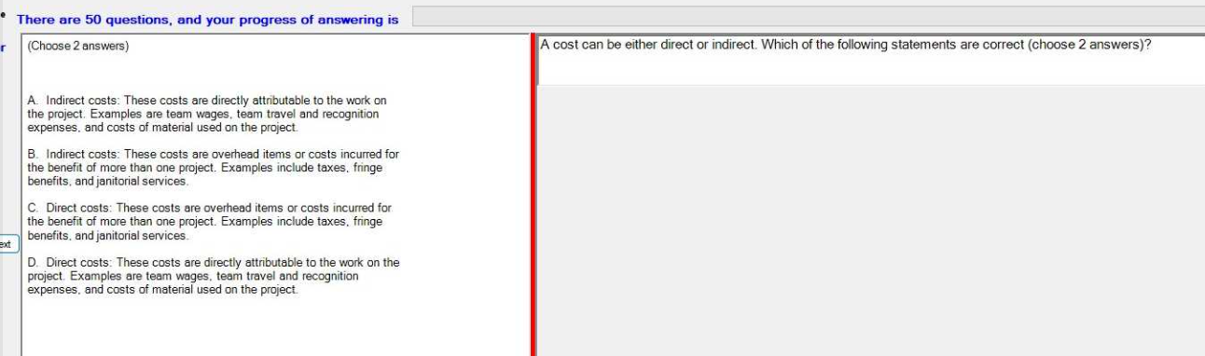

Db

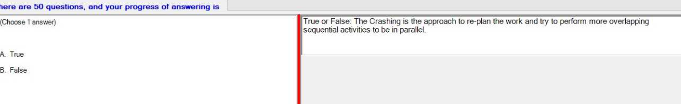

B (Crashing is a project management technique used to shorten the project schedule by adding more resources to critical path tasks without changing the project scope. The approach described in the question is more aligned with "fast tracking," which involves performing more activities in parallel to shorten the project timeline).

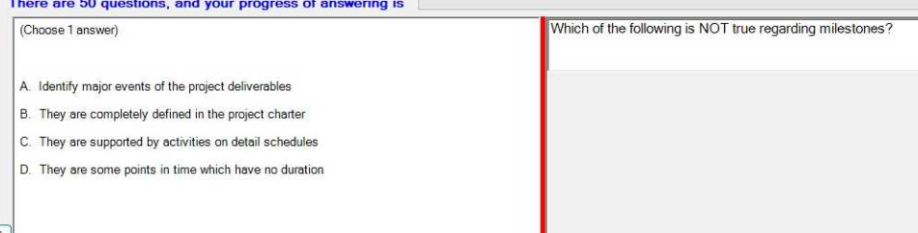

B

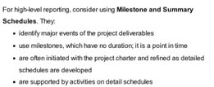

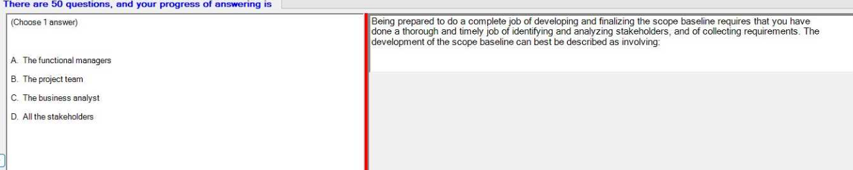

B

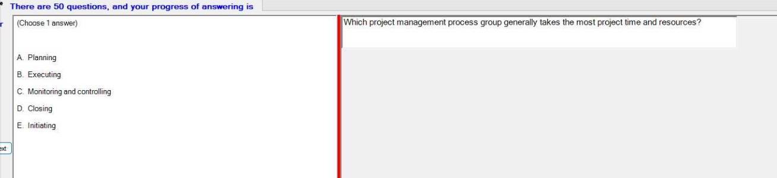

Executing

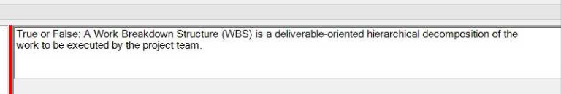

Project team T

Project manager F

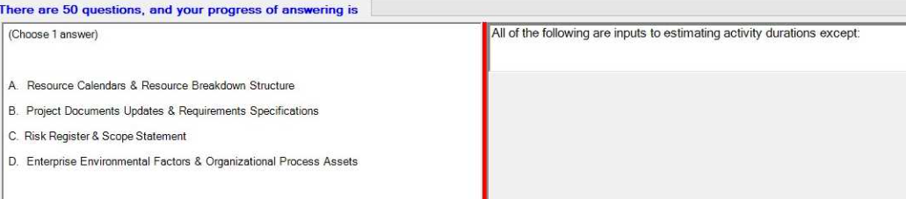

B

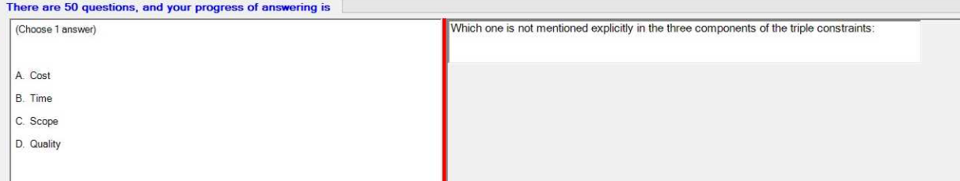

Cost, time ,scope D

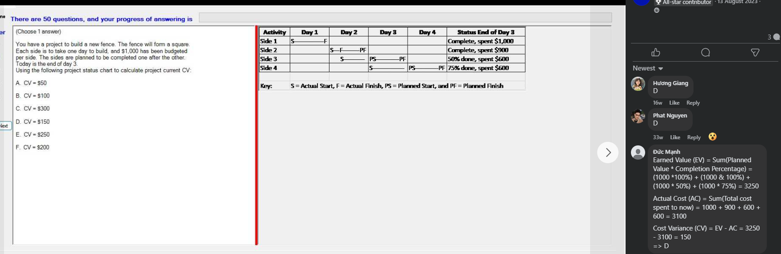

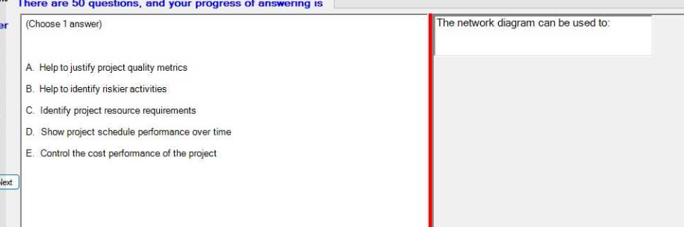

D

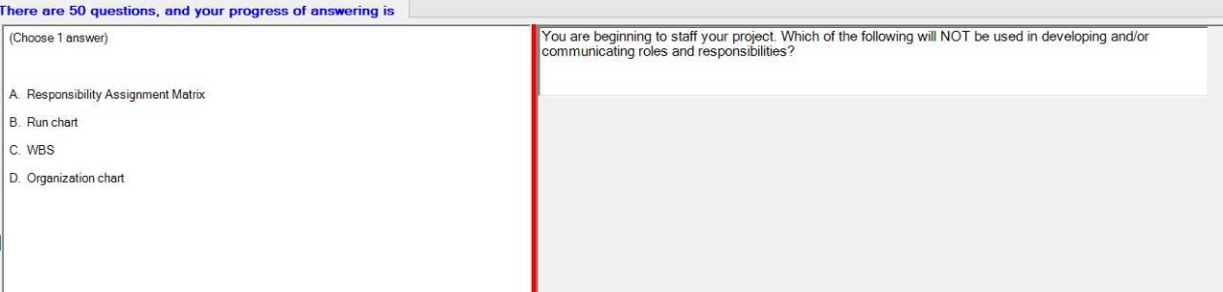

B

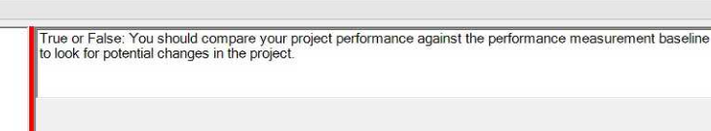  
True

**NOT Check**

|  | Quality control department | FALSE |
| --- | --- | --- |
|  | Quality control manager | TRUE |
|  | Performance reporting how resource | TRUE |
|  | Performing quality assurance | TRUE |
|  | Performing quality control | FALSE |
|  | Product quality | FALSE |
|  | Project quality | TRUE |
|  | Performance reporting good achievements | FALSE |
|  | Performance reporting how resource | TRUE |
|  | Product quality | FALSE |
|  | The Process Improvement Plan is a component of the project management plan | FALSE |
|  | The Cost Baseline is equal to the total of Activity Cost Estimates. | FALSE |
|  | The term resources only refers to | FALSE |
|  | The Fast Tracking is | FALSE |
|  | The Project Budget is equal to only the Cost Baseline budget. | FALSE |
|  | The Project Sponsor is responsible for stakeholder expectations management. | FALSE |
|  | When you choose to transfer your project risk to a third party | FALSE |
|  | When you are concerned that your estimates might not be correct, | FALSE |
|  | In the context of a project, change is always a bad thing | FALSE |
|  | It should not to add extra cost to the estimates when you are concerne | FALSE |
|  | If 'review online modules* called a start to finish relationship | FALSE |
|  | If 'review online modules* called a finishh to finish relationship | TRUE |
|  | Influence means you have the right to apply resources | FALSE |
|  | In a projectized organization, | FALSE |
|  | If you want to identify who your stakeholders are. | FALSE |
|  | Earned value integrates schedule, budget and quality and uses monetary values | FALSE |
|  | Earned value integrates schedule | FALSE |
|  | Scope creep | FALSE |
|  | Unregulated changes | FALSE |
|  | Using top-down estimating techniques | FALSE |
|  | A positive risk is a threat | FALSE |
|  | You should use parametric estimating when your historical | FALSE |

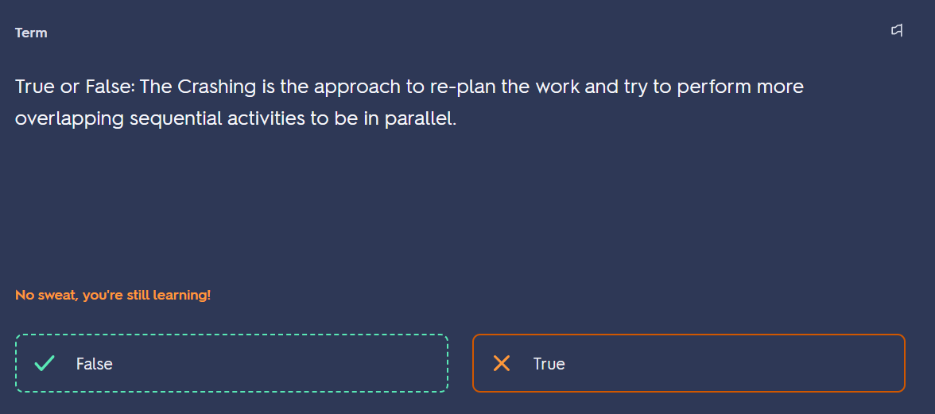

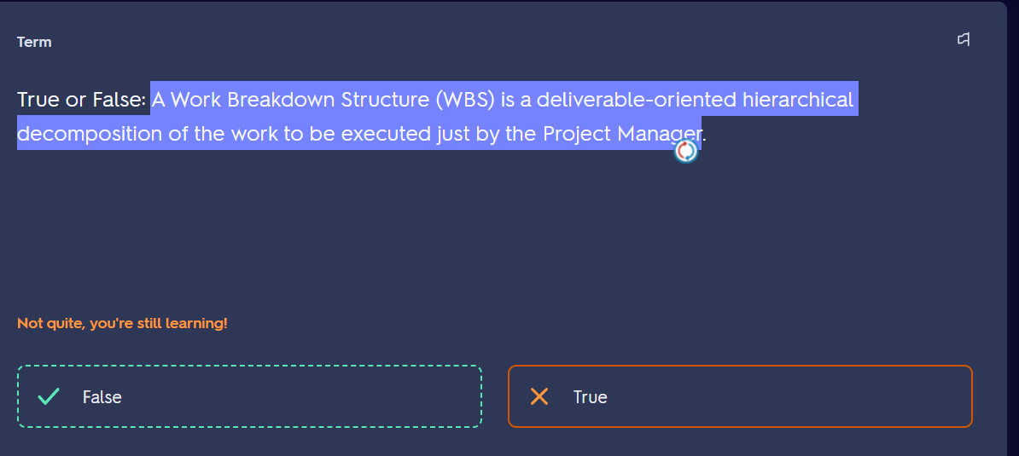

By project team not project manager

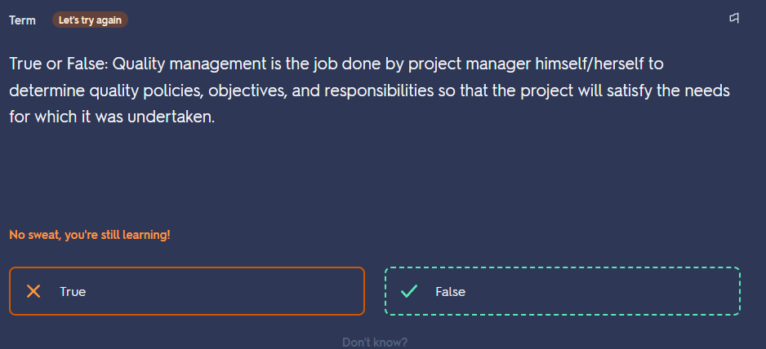

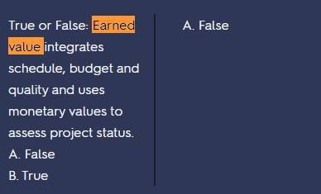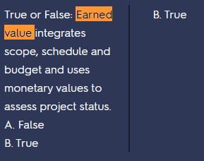

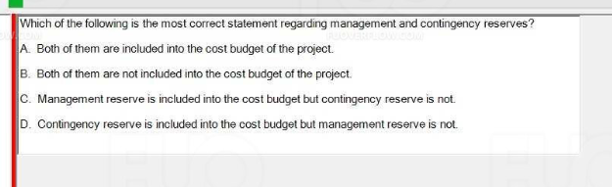

D

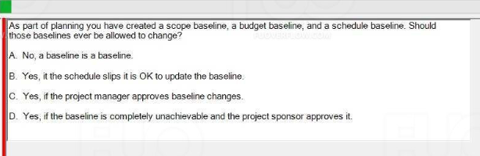

D

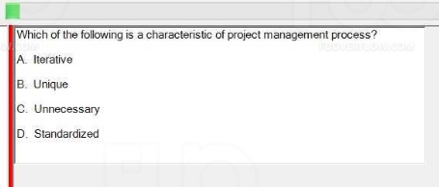

A

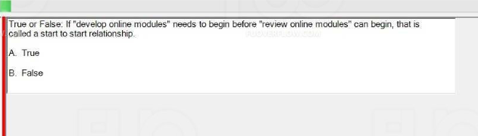

T

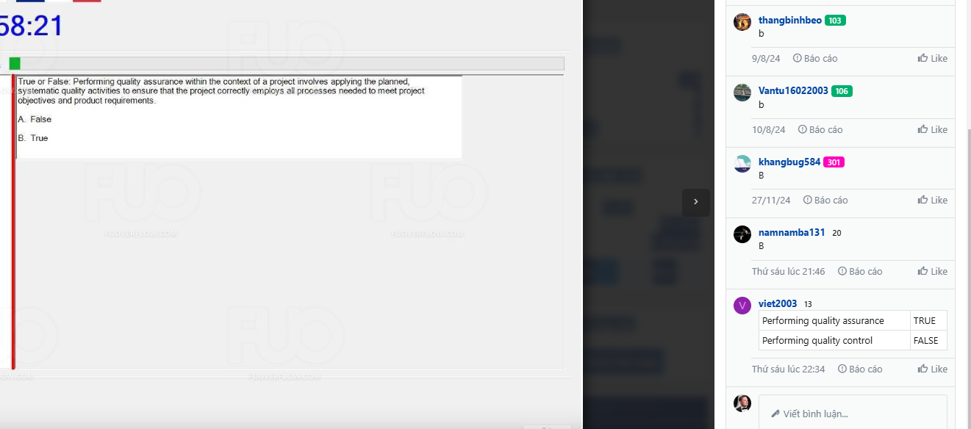

T

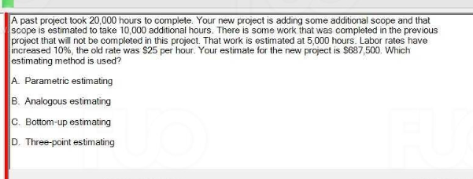

B

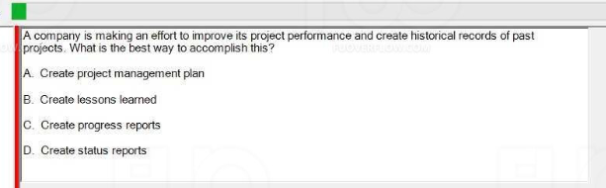

B

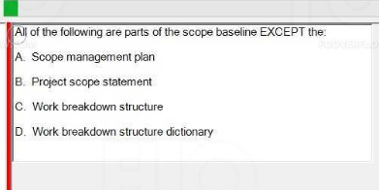

D hả

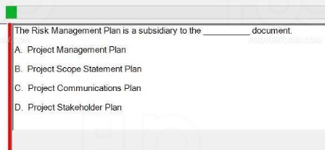

A

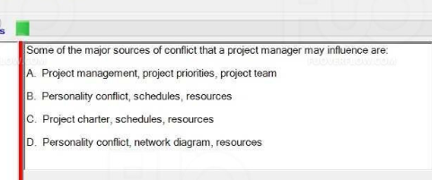

B

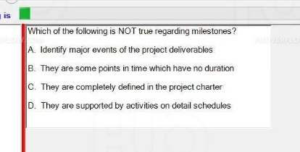

C